Microsoft Office 2010
Holiday Card Template Step-by-step
Learn more about Office 2010 at makeitgreat.com
Steps for Card 1 | Toolbar Tab and commands | Additional info
- Customize Exterior Photos | Insert > Picture > [choose your pic]
- Photo layout | Format > Wrap Text > In Front of Text | Once photo is set to “In Front of Text” you will be able to drag it location of your choosing on the page.
- Crop and resize | Format > Crop > Crop | It is best to use an image of similar proportions as in the template, however you can crop and resize any photo to fit.  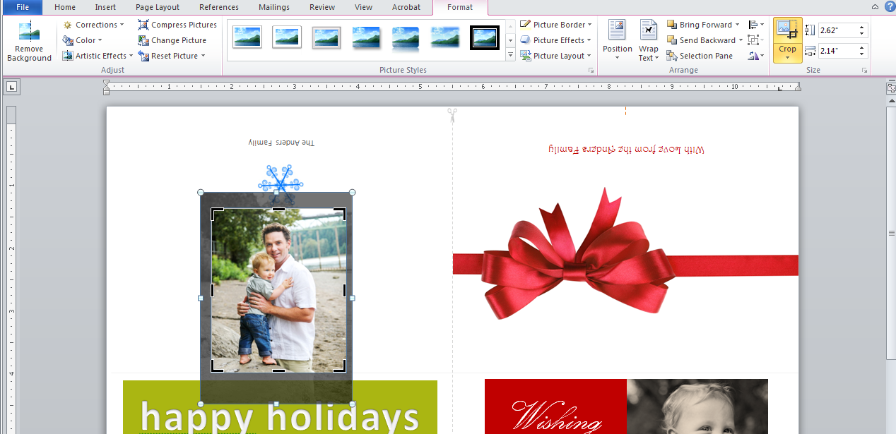
- Choose your photo effect | Format > Picture Styles (already showing in ribbon) | The template uses the first Picture Styles effect [Simple Frame, White]
  - Delete the template photo
  - Drag your new photo onto the card
  - Insert additional photos following the same steps
- Change angle of photos by selecting and “grabbing” the green handle at the top and rotating to the left or right. |  | 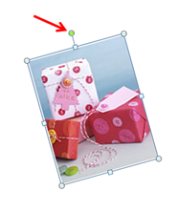
- Use shadow effects if desired | Format > Picture Effects > Shadow > Shadow Options | To achieve the exact effect as the template, use these settings for the tilted left and right photos on card 1  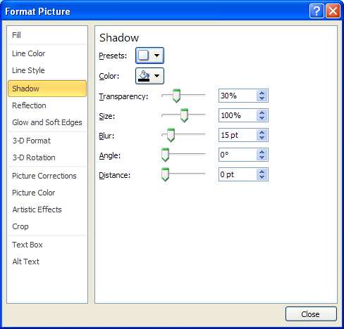
- Customize Exterior Text | Home tab | Click text in box, highlight text to change, type in new text. The upside down text will automatically flip right-side-up when clicked for editing.
- Customize Interior Text | Home tab | Follow the same instructions as above. Reposition text if necessary.  Tip: Note the location of the interior text for Card 1. It does not fall directly beneath the Card 1 exterior due to printing requirements. Be sure you are entering the text for the correct card.
Card 2
- Customize photos | Insert > Picture | Insert photos per instructions above
- Crop photos using template photos as markers | Format > Crop > Crop | You may need to resize and crop to fit the photo into the card’s dimensions.  Tip: Only delete and insert 1 photo at a time so you can use the template photos as size/place markers.
- Edit Exterior Text | Home tab | Be sure to change the inverted text on the “back” of the card “under” the ribbon, as it currently refers to a fictitious family.  You can also change the front text if you choose.
- Edit Interior Text |  | Follow the same instructions as for Card 1.
Printing
- Print using the double sided manual option  This will allow you to print the first side, take the printed paper, put it back into the printer exactly as it came out and then print the reverse side. Do a test run to make sure you are printing correctly. Your printer may vary on how it the paper should be inserted so be sure to do a test run. | File > Print > Manually Print on Both Sides
Cutting and Folding
- Cut along faint vertical dotted line
- Fold exactly in half

