Martha Stewart Living “Make Home Projects Great Contest”
Carol Dean Hatcher
November 22, 2010
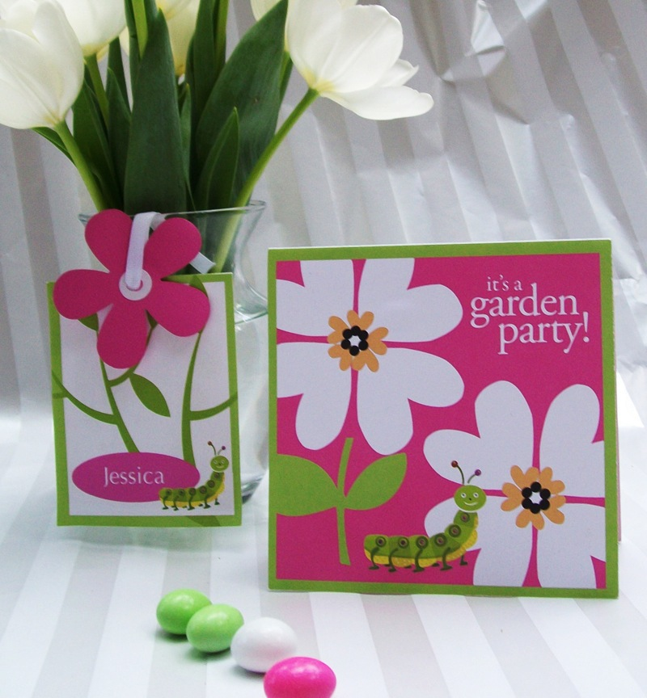

Step by Step on how to create
The “Garden Party” Invitation and Place Card

Materials:

110 # 8.5” x 11” bright white card stock
Ek Success PSPXL005 X-Large Retro Flower Punch (purchased from Amazon).

¼” white grosgrain ribbon 9” long

6” tall glass flower vase (kid size), fresh cut flowers

5.5” white square envelopes

white notebook paper hole reinforcements

single whole punch
Document Setup:

- Open Microsoft Office 2010 and select “blank document” from the “File” menu at the top. This will set the document at the default 8.5 x 11” size.
- The light green background will be created by inserting a 5.25” square two times: click the “Home” tab at the top, and at the far right of the menu, click insert “Shape” then, “Rectangles”.
- Select the square icon, and moving the cursor to the document, hold down the “shift” key and draw a square. The square should measure 5.25”
- Pick the color for the square by selecting “Format” from the top menu then “shape”. This will allow you to pick the color, also the attributes you want: solid color fill, no line, no gradient, etc. I used the color spectrum to pick the light green color.
- Position the green square at the top of the document and center it in the page.
- Click on the green square and “copy” under the main computer menu at the top; copy the square, now paste the square into the document. Align the square under the first square.
- Now save your work—you don’t want to lose anything.

Creating the Artwork

- To create the hot pink square, click on the “Home” tab then “shapes” > rectangles.
- Select the square icon, and moving the cursor to the document, hold down the “shift” key and draw a square. The square should measure 5”.
- Position the hot pink square at the center of the second square.
- To create the large white heart: by selecting “Format” from the top menu then “basic shapes”, then click on the heart icon. Create a heart that is 1.56” in height and 1.69” in width.
- Now format the heart by selecting “Format” > shape under the top menu. There you will adjust the heart’s attributes: white fill, no line, no gradient, no shadow.
- Grabbing the green dot at the top of the heart box, rotate the white heart into the correct position on the artwork, into the upper left corner of the square.
- Select the heart again, and duplicate it three times by the copy> paste commands. Using the green button rotate each heart and put into place--This will create the base of the first flower.
- To create the second flower base, select a heart and copy and paste it 4 more times. Rotate and position each heart.
- The white hearts are extending beyond the invitation, so click on the light green square at the top and copy and paste it on to your pasteboard. Now adjust the square to a piece that will overlay the white hearts like a border. Place this over the hearts, covering up where the hearts extend beyond the border. Do this three times—on for each side of the invitation.
- Create the small hearts the same way the large white hearts were created: by selecting “Format” from the top menu then “basic shapes”, then click on the heart icon. Make 5 small peach colored hearts per flower. Rotate and position each heart in the mile of the flower.
- Create inside of the flower by using black and white circle shapes: by selecting “Format” from the top menu then “basic shapes”, then click on the circle icon.

Create the Artwork (continued)

- Each flower center has one large white circle with 5 smaller black circles placed on top.
- Making the green leaves: This is the same process of the hearts but now we will use the arc shape:

- To create the green leaf: select “Format” from the top menu then “basic shapes”, then click on the arc icon. Select the arc icon, and moving the cursor to the document, draw an arc.
- Pick the color for the arc by selecting “Format” from the top menu then “shape”. This will allow you to pick the color, also the attributes you want: solid color fill, no line, no gradient, etc. I used the color spectrum to pick the light green color. This will expand the arc. Use the handles to shape the leaf.
- Using the green rotation tool, position the green arc onto the artwork
- Click on the arc and “copy” under the main computer menu at the top; copy and paste arcs and position until the arcs look like leaves.
- Create the stem by using the circle shape stretched into an oval. Use an oval the color of the background to layer on top of the green oval to create the stem.

Creating the “Garden Party “ type and caterpillar

- To create the “it’s a garden party,” break the text into three boxes so it can be positioned easier on the artwork. The typeface is Garamond with white fill and no outline.
- The caterpillar is clip art that was created in Microsoft Paint. Click “Insert” > Photo” > “picture from file” from the menu. Import original clip art from your computer or add other free Microsoft clipart at this website:
- http://office.microsoft.com/en-us/images/

Creating the invitation type and border

- On the second document page, copy and paste the green large square box from the first page-- (adjust the size of the box-- the box should measure 4.5” square),
- Insert a white picture box on top of the green box that is 4.25” square. Insert a text box with the invitation information. The type is set in Garamond. Once the invitation is printed, this will be cut out and glued or spray mounted on the inside.

Invitation information:

Spring has sprung,
And bees are humming!
We’re having a party,
And hope you’re coming!

Please join us for a
Garden Party honoring
Lauren Elizabeth
on her 5th birthday!

2:00 pm
Saturday, May 11, 2011
2721 Fernbank Avenue

Creating the Place Card

- The place card measures 3.5” x 4.5”.
- The light green background will be created by inserting a 4.5” rectangle on the third sheet of the document, Click the “Home” tab at the top, and at the far right of the menu, click insert “Shape” then, “Rectangles”.
- Select the rectangle icon, and moving the cursor to the document, draw a rectangle that is 4.5” high and 3.5” wide.
- Click on the rectangle and “copy” under the main computer menu at the top; copy the rectangle, now paste the rectangle under the first rectangle.
- Now insert a white picture box that measures 2.75” x 4.25” on top of the second green rectangle.

Creating the Artwork

- Making the green leaves: select “Format” from the top menu then “basic shapes”, then click on the arc icon. Select the arc icon, and moving the cursor to the document, draw an arc.
- Pick the color for the arc by selecting “Format” from the top menu then “shape”. This will allow you to pick the color, also the attributes you want: solid green color fill, no line, no gradient, etc. I used the color spectrum to pick the light green color. This will expand the arc. Use the handles to shape the leaf.
- Using the green rotation tool, position the green arc onto the artwork
- Click on the arc and “copy” under the main computer menu at the top; copy and paste arcs. Rotate and position until the arcs until they look like leaves.
- Create the stem by using the circle shape stretched into an oval. Use an oval the color of the background to layer on top of the green oval to create the stem.
- Draw a pink oval and on top of the oval insert a text box. Insert the name of the child in white type (in this case, Jessica). The type is Garamond.
- Copy and paste the caterpillar art on top of the pink oval.

Printing and Assembling the Invitation and Place Card

- Print the invitation and place card. Adjust printer settings to “bleed” to accommodate the whole card.

- Using the flower punch, punch a flower from the pink swatch square provided on the template.

- Reinforce the hole with the white notebook paper hole reinforcement.

- Cut out the place card and fold card at middle. Glue the two sides together, and punch a hole about ¼” down from the top of the card. Take the pink punched flower, line it up with the hole on the place card, and thread the grosgrain ribbon through to the other side. Secure the place card to the flower vase in the front by draping over the rim of the vase. Add water and flowers to the vase.

