it’s a

garden

party!

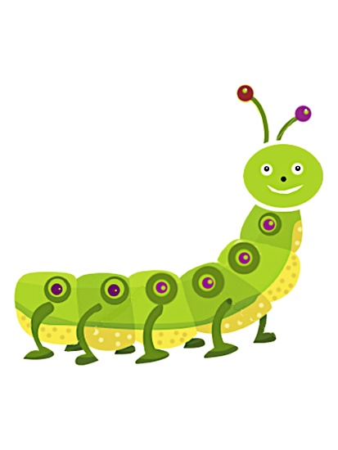

Inside Invitation:

Spring has sprung,

And bees are humming!

We’re having a party,

And hope you’re coming!

Please join us for a

Garden Party honoring

**Lauren Elizabeth   
on her 5th birthday!**

2:00 pm

Saturday, May 11, 2011

2721 Fernbank Avenue



Pink swatch to use for flower punch--Ek Success PSPXL005 X-Large Retro Flower Punch

(purchased from Amazon).

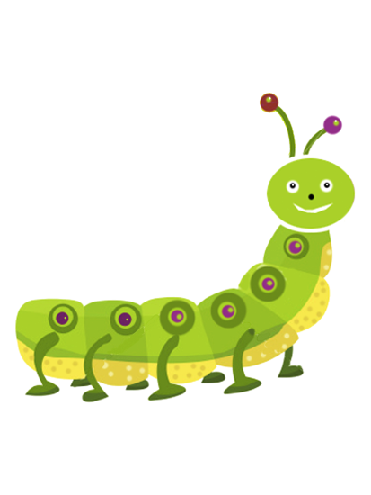

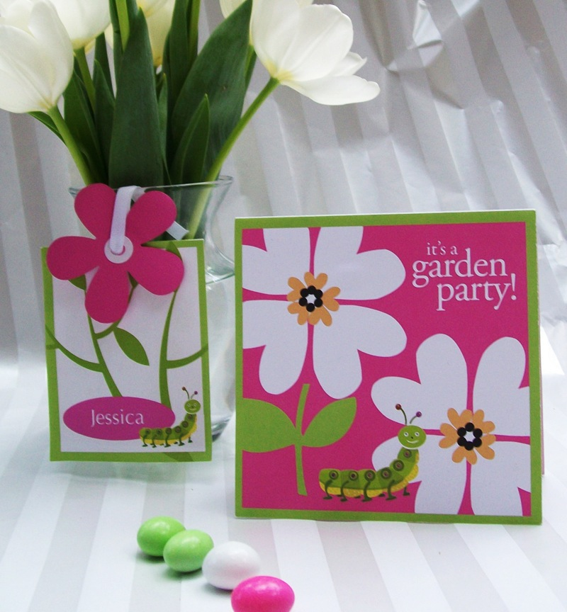

Pink paper square for Ek Success PSPXL005 X-Large Retro Flower Punch (purchased from Amazon).

Jessica